1. **otrouting documentation**

The pupose of this document is to present the scripts and the function used to perform routing on opentravellers:

it includes:

- a python script enabling to import openstreetmap data in pgsql database and create a routable database

- a sql script for shortest path calculation between a starting and ending point

- a second sql script enabling to get the route information from a list of point (route information based on osm tags of the closest way)

# References

1. [1] *01_postgre+postgis installation and OSM data import_v2.docx*

# pre-requisites

## Postgresql, postgis, osm2pgsql

* 1. See [1]

pgpass shall also be installed

## Pgrouting extension

1. *apt update*
2. install pgrouting
3. *apt install postgresql-10-pgrouting*

## Create db_osm_routing postgresql data base with postgis and pgrouting extension

1. See ref [1] if needed to create super user *user*
2. Create database
3. *sudo -u postgres createdb -O user db_osm_routing*
4. Open db
5. *psql -h localhost -U user db_osm*
6. Password for user user: xxxxx
7. *# CREATE EXTENSION postgis;*
8. *# SELECT postgis_full_version();*
9. 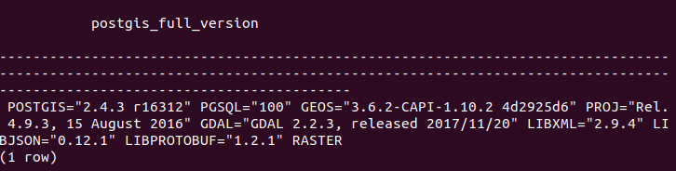

press “q” to quit pgsql answer

1. *# CREATE EXTENSION pgrouting;*
2. *# SELECT * FROM pgr_version();*
3. 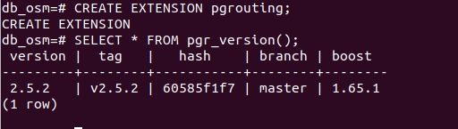
4. press “ctrl+z” to quit sql db

## pgpass

1. .pgpass file shall be used so as to avoid to use password in the osm2pgsql line
2. <https://linuxandryan.wordpress.com/2013/03/07/creating-and-using-a-pgpass-file/>
3. *cd ~*
4. *touch .pgpass*
5. *nano .pgpass*
6. localhost:5432:db_osm_routing:user:xxxxx
7. *chmod 0600 .pgpass*

## Python

The following extension are used:

import sys

import psycopg2

import time

import math

import os

import subprocess

# OSM data import and formating

## Python script

Osm data are imported and formatted through the python script *otrouting_py/otrouting_v1.3.py*

## Input data

### Input data location

Input data shall be fill in the beginning of the ot_routing_v1.3.py script

Open python script to fill the input data

*nano ot_routing_v1.3.py*

### Database identification

Identification parameters to connect the database

*glob_db = 'db_osm_routing'*

*glob_user = 'user'*

*glob_host = 'localhost'*

*glob_port = '5432'*

*glob_password = 'xxxxx'*

### osm input data to be imported

a table of osm input data to be imported, data will be imported from [http://download.geofabrik.de](http://download.geofabrik.de/)

osm input data shall be formatted as presented below:

http://download.geofabrik.de/europe/andorra.html **→**  ["europe", "andorra"]

*glob_t_input = []*

*#http://download.geofabrik.de*

*#MONACO - ANDORRA ######################*

*glob_t_input.append(["europe", "andorra"])*

*glob_t_input.append(["europe", "monaco"])*

*#FRANCE ###################################*

*#glob_t_input.append(["europe", "france", "alsace"])*

*#glob_t_input.append(["europe", "france", "aquitaine"])*

*#glob_t_input.append(["europe", "france", "auvergne"])*

*#glob_t_input.append(["europe", "france", "basse-normandie"])*

## Script run

### Execution command

Make otrouting file executable

*Chmod 777 ot_routing_v1.3.py*

Run python script

./*ot_routing_v1.3.py*

### script architecture overview

The script will basically:

1/ initialise database,

1.1/ Remove osm import temporary table from db:

* + 1. § DROP TABLE IF EXISTS otrouting_points

1. § DROP TABLE IF EXISTS planet_osm_*
2. 1.2/ create extension postgis and pgrouting if not exists in db
   1. § CREATE EXTENSION IF NOT EXISTS postgis
3. § CREATE EXTENSION IF NOT EXISTS pgrouting
   * 1. 1.3/ Create table requested for otrouting requests in db:
4. § CREATE TABLE IF NOT EXISTS otrouting_master
   1. § CREATE TABLE IF NOT EXISTS otrouting_points
   2. § CREATE TABLE IF NOT EXISTS otrouting_ways
5. § CREATE INDEX IF NOT EXISTS otrouting_ways_geom_center_gist
   1. § CREATE INDEX IF NOT EXISTS otrouting_ways_id
   2. 2/ upload data from download.geofabrik.de
6. > wget -O europe_andorra-latest.osm.bz2 “http://download.geofabrik.de/europe/andorra-latest.osm.bz2”
7. > wget -O europe_andorra.poly “http://download.geofabrik.de/europe/andorra.poly”
9. 3/ import osm data with osm2pgsql
10. > osm2pgsql --slim -C 100 -d db_osm_routing -U user -H localhost -P 5432 europe_andorra-latest.osm.bz2
11. NOTE: .pgpass have to be created so as to avoid to have to fill manually the password
13. *4/ create routable table, otrouting_points is populated with new summits, otrouting_ways is populated with new vertex*

## Output data

### otrouting_master pgsql table

This table enable to record all osm data import.

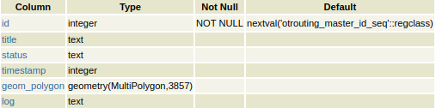

**status:**

**- *completed*** if data in otrouting_ways and otrouting_points tables corresponds to this import

- ***obsolete*** if data in otrouting_ways and otrouting_points tables have been overseed by another import more recent

**geom_polygon**: corresponds to the .poly file that describes the extent of the imported region from [http://download.geofabrik.de](http://download.geofabrik.de/)

**log: l**og with the versoin of the script used for this import, the number of point imported in otrouting_points and otroutingways tables

### otrouting_points pgsql table

This table contains all the summit of the routable network generated from osm data

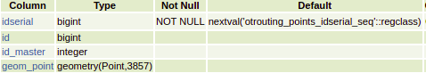

### otrouting_ways pgsql table

This table contains all the edge of the routable network generated from osm database

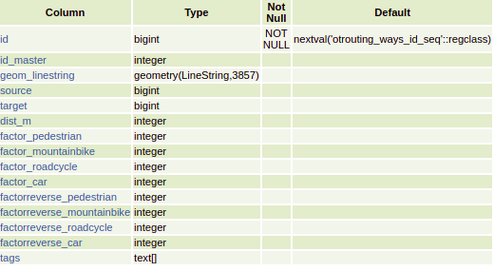

## Examples of postgis call

### Create table with postgis entry and index

*CREATE TABLE IF NOT EXISTS otrouting_master(id serial PRIMARY KEY, title text, status text, log text, timestamp int, geom_polygon geometry(MultiPolygon,3857));*

*CREATE INDEX IF NOT EXISTS otrouting_master_geom_polygon ON otrouting_master USING GIST (geom_polygon);*

*CREATE TABLE IF NOT EXISTS otrouting_points(idserial bigserial PRIMARY KEY, id bigint, id_master int, geom_point geometry(Point,3857));*

*CREATE INDEX IF NOT EXISTS otrouting_points_geom_point_gist ON otrouting_points USING GIST (geom_point);*

*CREATE TABLE IF NOT EXISTS otrouting_ways(id bigserial PRIMARY KEY, id_master int, geom_linestring geometry(Linestring,3857), source bigint, target bigint, dist_m int, factor_pedestrian int, factor_mountainbike int, factor_roadcycle int, factor_car int, factorreverse_pedestrian int, factorreverse_mountainbike int, factorreverse_roadcycle int, factorreverse_car int, tags text[]);*

*CREATE INDEX IF NOT EXISTS otrouting_ways_geom_linestring_gist ON otrouting_ways USING GIST (geom_linestring);*

### Insert postgis multipolygon geometry

*INSERT INTO otrouting_master (title, status, timestamp, geom_polygon) VALUES ('europe_andorra','started', 1647031730.99, ST_Transform(ST_GeomFromText('MULTIPOLYGON(((1.516233 42.4276,1.496092 42.43182,1.455187 42.43475,1.446745 42.43823)))', 4326), 3857));*

### Create, transform and insert postgis point geometry

create point from coordinate

*ST_PointFromText('POINT(1.7359278 42.5436511)', 4326);*

transform coordinate from EPSG4326 to 3857

*ST_Transform(ST_PointFromText('POINT(1.7359278 42.5436511)', 4326), 3857);*

insert data into table

*INSERT INTO otrouting_points (id, id_master, geom_point) VALUES(3655224911, 151, ST_Transform(ST_PointFromText('POINT(1.7359278 42.5436511)', 4326), 3857));*

### Create and insert postgis linestring geometry

*INSERT INTO otrouting_ways (id_master, geom_linestring, source, target, dist_m, factor_pedestrian, factor_mountainbike, factor_roadcycle, factor_car, factorreverse_pedestrian, factorreverse_mountainbike, factorreverse_roadcycle, factorreverse_car, tags) VALUES(152, ST_GeomFromText('LINESTRING(193242.598749888 5242766.84650556,193224.531596532 5242753.24816413,193216.516593195 5242747.49153884,193205.763130383 5242740.13333786,193204.004282429 5242739.39298531)',3857), 3655224911, 4817024439, 34, 152, 152, 132, 97, 1, -1, -1, -1, ARRAY ['highway','primary','maxspeed','30','oneway','yes','ref','N 22','surface','asphalt'])*

## Clean working directory

Clean working directory and remove osm imported and log files

*chmod 777 clean.txt*

*./clean.txt*

the following function will be executed:

*rm -rf wget-log\**

*rm -rf *.poly*

*rm -rf *.osm.bz2*

# otrouting_getrouting sql function

## Sql function

Import sql function from *otrouting_sql/otrouting_getrouting_v1.5.sql* into db_osm_routing table

FUNCTION otrouting_getrouting(

lon1 FLOAT,

lat1 FLOAT,

lon2 FLOAT,

lat2 FLOAT,

routingtype TEXT)

RETURNS TABLE (lonlat text[])

routingtype can have the following values: pedestrian / mountainbike / roadcycle / car

## Examples

*SELECT * FROM otrouting_getrouting(1.7358052810252, 42.54356918667, 1.73470359630932, 42.5435625682116, 'pedestrian');*

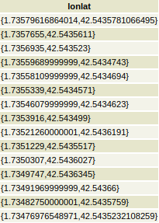

## Examples of postgis call

SELECT otrouting_ways.id AS id,

ST_Distance(otrouting_ways.geom_linestring, point1) AS dist,

otrouting_ways.geom_linestring,

otrouting_ways.source,

otrouting_ways.target,

otrouting_ways.factor_pedestrian,

otrouting_ways.factor_mountainbike,

otrouting_ways.factor_roadcycle,

otrouting_ways.factor_car,

otrouting_ways.factorreverse_pedestrian,

otrouting_ways.factorreverse_mountainbike,

otrouting_ways.factorreverse_roadcycle,

otrouting_ways.factorreverse_car

INTO tableway1 FROM otrouting_ways WHERE ST_Intersects(otrouting_ways.geom_linestring, ST_MakeEnvelope(lonmin_loc, latmin_loc, lonmax_loc, latmax_loc, 3857)) AND factor_car > 0 ORDER BY dist ASC LIMIT 1;

ST_ClosestPoint(tableway1.geom_linestring, point1)

ST_AsText(ST_Transform(linestring1,4326))

*ST_GeomFromText('LINESTRING(' || text11 || ')',3857);*

*ST_GeomFromText('MULTILINESTRING(('|| text11*

*|| '),('*

*|| text22*

*|| '))',3857);*

*ST_AsText(ST_CollectionExtract(ST_Split(tableway1.geom_linestring, proj1_linestring),2));*

*ST_Distance(_temp_otrouting_points.geom_point, proj1)*

# otrouting_getrouteinfo sql function

## Sql function

Import sql function from *otrouting_getrouteinfo_v1.4sql* into db_osm_routing table

FUNCTION otrouting_getrouteinfo(

arraysources TEXT[],

threeshold_distProj_m FLOAT)

RETURNS TABLE (

geom_source TEXT,

geom_proj TEXT,

ids_way_source_target BIGINT[],

dist DOUBLE PRECISION,

tags text[]

)

arraysources is a list of coordinate in EPSG4326, as example: ARRAY['POINT(1.533258 42.513852)','POINT(1.533126 42.513875)'

threeshold_distProj_m is a maximum distance to consider a projection between an input coordinate and a route

## Examples

*SELECT * FROM otrouting_getrouteinfo(ARRAY['POINT(1.533158 42.513852)','POINT(1.533226 42.513875)','POINT(1.533071 42.514391)'], 30.0);*



*SELECT * FROM otrouting_getrouteinfo(ARRAY['POINT(1.533158 42.513852)','POINT(1.533226 42.513875)','POINT(1.533071 42.514391)'], 10.0);*



## Examples of postgis call

*dist_m := ST_DistanceSphere(point1_4326, point11_4326);*

*dist_3852 := ST_Distance(point1, point11);*

*point1 := ST_Transform(ST_GeomFromText(arraysources[i],4326),3857);*

*lon1 := ST_X(point1);*

*lat1 := ST_Y(point1);*

*ST_Intersects(otrouting_ways.geom_linestring, ST_MakeEnvelope(lonmin_loc, latmin_loc, lonmax_loc, latmax_loc, 3857))*